
College of Engineering and Technology

Project Batch ID
Project Work – Student Hand Book

Name of student | Register Number | Department | Mobile Number | Email ID
B S Vikash Srikanth | RA2311026010583 | CINTEL | 8754829020 | vs7189@srmist.edu.in
S Ravi Prakash | RA2311026010591 | CINTEL | 9342803262 | rp2382@srmist.edu.in
Degree/ program | B.Tech | Specialisation | Computer Science & Engineering With Specialization In Artificial Intelligence & Machine Learning
Academic Year | 2025-2026 (Even) | Semester | 6

Title of the Project: |  | LUNG CANCER DETECTION AND MULTI-CLASS CLASSIFICATION USING CT IMAGES WITH EXPLAINABLE AI DIAGNOSIS
Project Site / Location |  | SRM IST, Kattankulathur, Chengalpattu District-603203
Name and address of the company / organisation (Applicable for projects with industry or industry support) |  | SRM IST, Kattankulathur, Chengalpattu District-603203
Supervision Team
 | Supervisor |  | Co-Supervisor | External Supervisor (If applicable)
Name | Dr. N Gopinath
Designation | Assistant Professor
Department | Department of Computational Intelligence
Campus | SRM INSTITUTE OF SCIENCE AND TECHNOLOGY,  Kattankulathur |  | Kattankulathur | Kattankulathur
Telephone | 9952327939
E-mail | gopinatn2@srmist.edu.in

Course Code | 21CSP302L | Course Title | Project
Mission Statement

To design and develop a hierarchical lung cancer diagnostic system capable of classifying CT scan images into benign/malignant categories and cancer subtypes (Adenocarcinoma, Large Cell, Squamous Cell, Normal) by leveraging ResNet50-based deep learning models with dual-layer Explainable AI (Grad-CAM and LIME), enabling accurate, interpretable, and clinically actionable diagnostic support for radiologists and oncologists.
Problem (or) Product Description:
Lung cancer remains one of the leading causes of cancer-related mortality worldwide, where early and accurate detection from CT scan images is critical for improving patient survival rates. Current diagnostic methods rely heavily on manual radiological interpretation that is time-consuming, subjective, and prone to human error, while existing AI-based systems often lack interpretability and clinical context in their predictions.ping sounds, and varying recording conditions, leading to reduced accuracy in real-world scenarios.
Traditional lung cancer detection methods and basic automated AI systems rely on single-stage classification approaches, which are often ineffective in distinguishing between cancer subtypes and lack the explainability needed for clinical adoption and trust.
This project proposes a hierarchical lung cancer diagnostic system that analyzes chest CT scan images using advanced image preprocessing and dual ResNet50 deep learning models to accurately classify malignancy and identify cancer subtypes with full explainable AI support.
The system integrates dual ResNet50 models — one for binary screening (Benign vs Malignant) and another for four-class subtype classification (Adenocarcinoma, Large Cell, Squamous Cell, Normal) — combined through a hierarchical diagnostic pipeline with Grad-CAM and LIME explainability layers and an automated clinical narrative generation engine. The modular design supports continuous improvement and scalability of the diagnostic system.
Assumptions and Constraints :
Assumptions:
Input CT scan images contain identifiable lung tissue regions.
CT scan data can be collected from reliable medical imaging datasets such as the IQ-OTH/NCCD Lung Cancer Dataset.
The dataset used for training includes diverse cancer subtypes and varying imaging conditions.
Pretrained ResNet50 models with ImageNet weights are suitable for transfer learning on medical imaging tasks.
Internet connectivity is available for data retrieval and model integration when required.
Constraints:
Model performance depends on the quality of CT scan images and presence of imaging artifacts.
Imaging factors such as low contrast, noise, and scan resolution may affect classification accuracy.
High computational resources (GPU) may be required for processing CT images and running deep learning models.
The system is trained on a specific dataset and may not generalize to all CT scanner types or patient populations.
Real-time processing performance may vary depending on system capabilities and image resolution.

Stakeholders :
Radiologists and Oncologists:
Medical professionals who use CT scan-based diagnostic tools for lung cancer screening, subtype identification, and treatment planning.
Medical Researchers:
Professionals studying lung cancer detection, classification, and explainable AI in clinical diagnostics using automated diagnostic systems.
Developers / AI Engineers:
Responsible for designing, training, and improving the image processing pipelines and deep learning models used for lung cancer classification.
System Administrator:
Responsible for deploying the system, monitoring its performance, managing data pipelines, and updating models with new CT scan datasets to ensure continuous improvement.
Healthcare Organizations / Hospitals:
Medical institutions, cancer research centers, and healthcare organizations that can utilize this system for large-scale lung cancer screening, diagnostic support, and clinical decision-making.

Division of work and contributors of SPRINT 1 [ Include Daily Scrum of Sprint 1] SPRINT 1 — Problem Analysis, Dataset Preparation and System Design
Duration: 01 Feb 2026 – 25 Feb 2026
Division of Work:

B S Vikash Srikanth:
Conducted an in-depth literature survey on lung cancer detection techniques using CT scan images, including traditional image processing methods, CNN-based classification models, and explainable AI approaches. Performed comparative analysis and identified research gaps such as limited interpretability of deep learning predictions, lack of hierarchical diagnostic pipelines, and insufficient clinical context in automated systems. Designed the overall system architecture using a modular pipeline approach (Image Preprocessing → Binary Classification → Subtype Classification → XAI Analysis → Clinical Report Generation). Defined the complete workflow including CT image upload, CLAHE enhancement, ResNet50 inference, Grad-CAM/LIME visualization, and clinical narrative output. Planned integration of dual ResNet50 models and contributed to system design documentation and architecture planning.

S Ravi Prakash:
Handled dataset collection by gathering chest CT scan images from the IQ-OTH/NCCD Lung Cancer Dataset, organized into Benign, Malignant, and Normal categories along with cancer subtype labels (Adenocarcinoma, Large Cell, Squamous Cell). Performed extensive preprocessing including image normalization, CLAHE contrast enhancement, median filtering, and morphological operations. Converted grayscale CT images into 224×224 RGB tensors suitable for ResNet50 input. Conducted exploratory data analysis on class distributions (EDA) to identify class distribution patterns and understand dataset characteristics. Assisted in defining preprocessing pipelines and contributed to setting up the PyTorch development environment and required tools.

Collaborative Work:
Both contributors jointly designed the system architecture, finalized dataset preparation and preprocessing strategies, and defined the hierarchical two-stage classification approach. They worked together on documentation, sprint planning, and defining system requirements. Initial project setup, Flask web application scaffolding, and workflow validation were also completed collaboratively.

Sprint 1 Backlog (User Stories):

F1 – Problem Understanding and Literature Survey [COMPLETED 10/02/2026]
- Reviewed existing lung cancer detection and classification systems using CT imaging.
- Identified limitations in existing AI diagnostic systems regarding interpretability and clinical utility.
- Analyzed the need for hierarchical classification with explainable AI support.

F2 – Dataset Collection and Preprocessing [COMPLETED 18/02/2026]
- Collected chest CT scan images from the IQ-OTH/NCCD Lung Cancer Dataset
- Performed normalization, CLAHE enhancement, and morphological preprocessing
- Converted CT images into 224×224 RGB tensors for ResNet50 input
- Prepared dataset with train/validation/test splits for model training

F3 – System Architecture Design and Planning [COMPLETED 25/02/2026]
- Designed modular hierarchical system architecture
- Defined processing stages: CT image → preprocessing → binary classification → subtype classification → XAI → report
- Planned integration of dual ResNet50 models with Grad-CAM and LIME explainability
- Ensured scalability and clinical relevance of the diagnostic pipeline

Daily Scrum Meeting Log — Sprint 1

Week 1 (Problem Understanding and Planning):
- Conducted Sprint kickoff and finalized project scope.
- Assigned roles and responsibilities.
- Completed literature review on AI-based lung cancer diagnostic systems.
- Identified research gaps in explainability and hierarchical classification.
- Documented initial project requirements.

Week 2 (Dataset Collection and Preprocessing):
- Collected chest CT dataset from IQ-OTH/NCCD Lung Cancer Dataset
- Performed preprocessing: normalization, CLAHE enhancement, morphological filtering
- Generated 224×224 RGB tensor representations from grayscale CT scans
- Conducted exploratory data analysis on class distributions
- Identified important image features and preprocessing parameters

Week 3 (Architecture Design and Setup):
- Designed hierarchical diagnostic system architecture and workflow pipeline
- Defined image preprocessing and enhancement modules
- Planned dual ResNet50 model integration with XAI layers
- Set up PyTorch and Flask development environment
- Resolved initial CUDA and model loading issues

Division of work and contributors of SPRINT 2 [ Include Daily Scrum of SPRINT 2]
SPRINT 2 — Model Development and Evaluation
Duration: 26 Feb 2026 – 25 Mar 2026

Division of Work:

B S Vikash Srikanth:
Developed the core classification pipeline by implementing ResNet50 with transfer learning (ImageNet weights) for binary classification (Benign vs Malignant). Worked on implementing the image preprocessing pipeline using CLAHE enhancement and ensured compatibility with PyTorch models. Designed the hierarchical two-stage inference flow and implemented the Grad-CAM explainability layer for activation visualization. Focused on optimizing model performance and improving classification accuracy by refining image augmentation and model fine-tuning strategies.

S Ravi Prakash:
Implemented the four-class subtype classification model (ResNet50) for identifying Adenocarcinoma, Large Cell, Squamous Cell, and Normal tissue from CT images. Integrated the LIME (Local Interpretable Model-agnostic Explanations) explainability module for superpixel-based feature attribution. Worked on handling real-world imaging challenges such as varying contrast levels and scan artifacts. Assisted in tuning model hyperparameters and validating prediction outputs for accuracy and clinical consistency.

Collaborative Work:
Both contributors worked together on integrating both classification models into a unified hierarchical pipeline. They validated model outputs, tested classification accuracy across all classes, and refined the dual-layer XAI mechanism. They also collaborated on debugging, performance evaluation, and documentation of model implementation.

Sprint 2 Backlog (User Stories):

F4 — Image Enhancement and Preprocessing Pipeline[COMPLETED 08/03/2026]
Implemented CLAHE-based image enhancement and improved preprocessing pipeline for better model input.

F5 — ResNet50 Model Training and Integration [COMPLETED 15/03/2026]

Implemented CLAHE-based image enhancement and improved preprocessing pipeline for better model input.

F6 — Hierarchical Classification and Grad-CAM Pipeline [COMPLETED 20/03/2026]
Developed hierarchical inference pipeline connecting binary screening to subtype classification with Grad-CAM visualization.

F7 — Model Testing and Performance Evaluation [COMPLETED 25/03/2026]
Tested system performance using CT scan images and evaluated classification accuracy with confusion matrices.

Daily Scrum Meeting Log — Sprint 2

Week 1 (Feature Extraction and Setup):
- Conducted Sprint 2 kickoff and defined implementation tasks
- Implemented CLAHE-based CT image enhancement pipeline
- Improved preprocessing pipeline for ResNet50 compatibility
- Set up PyTorch GPU environment for model training

Week 2 (Model Development and Integration):
- Trained ResNet50 binary classification model (Benign vs Malignant)
- Trained ResNet50 four-class subtype classification model
- Implemented Grad-CAM activation mapping for both models
- Generated initial predictions and validated outputs on test set

Week 3 (Optimization and Fusion):
- Developed hierarchical classification pipeline
- Tuned model hyperparameters for better accuracy
- Reduced false positive rates and improved classification robustness
- Tested predictions on multiple CT scan images

Week 4 (Evaluation and Refinement):
- Evaluated system performance using accuracy, precision, recall, and F1-score
- Compared binary vs four-class model results
- Fixed bugs and improved inference pipeline efficiency
- Finalized Sprint 2 deliverables

Division of work and contributors of SPRINT 3 [ Include Daily Scrum of Sprint 3] SPRINT 3 — System Integration, Explainability and Final Deployment
Duration: 26 Mar 2026 – 10 Apr 2026

Division of Work:

B S Vikash Srikanth:

Led the final system integration by combining all modules including CT image preprocessing, hierarchical classification, and dual-layer XAI into a unified Flask web application. Implemented the clinical narrative generation engine to produce structured diagnostic reports from model predictions and Grad-CAM analysis. Focused on optimizing system performance and ensuring smooth end-to-end execution from CT image upload to final clinical report. Worked on improving prediction reliability and handling edge cases in varied CT scan qualities.

S Ravi Prakash:
Handled system testing and validation using different CT scan images to evaluate diagnostic performance under various conditions. Implemented the interactive web dashboard with dual-sector analysis (binary screening and subtype classification) and ensured that the system outputs predictions along with confidence scores, Grad-CAM heatmaps, LIME explanations, and clinical notes. Worked on refining the UI/UX and improving robustness of the diagnostic pipeline. Assisted in preparing final outputs such as downloadable PDF reports and system documentation.

Collaborative Work:
Both contributors worked together on complete system integration, debugging, and performance optimization. They conducted end-to-end testing, validated results, and ensured the system meets project objectives. Documentation, report preparation, and final presentation were completed collaboratively.

Sprint 3 Backlog (User Stories):

F8 — Flask Web Application Integration [COMPLETED 02/04/2026]
Integrated all modules into a complete end-to-end Flask web application pipeline.

F9 — End-to-End Testing and Validation [COMPLETED 05/04/2026]

Tested system using diverse CT scan images and evaluated diagnostic accuracy and robustness.

F10 — XAI Visualization and Clinical Report Generation [COMPLETED 08/04/2026]
Implemented display of predictions, confidence scores, Grad-CAM heatmaps, LIME explanations, and clinical reports.

F11 — Final Documentation and Deployment [COMPLETED 10/04/2026]

Prepared final report, documentation, and project demo for submission.

Daily Scrum Meeting Log — Sprint 3

Week 1 (Integration and Pipeline Development):
- Conducted Sprint 3 kickoff and finalized integration plan
- Combined preprocessing, classification, and XAI modules into Flask backend
- Implemented end-to-end diagnostic workflow with web interface
- Identified and fixed integration issues between frontend and backend

Week 2 (Testing and Optimization):
- Tested system with multiple CT scan images across all classes
- Improved handling of low-contrast and artifact-heavy CT scans
- Optimized model inference performance and page response time
- Fixed bugs and improved application stability

Worksheet / Data collection / Observation etc Results and Observations
Model 1 — ResNet50 Binary Classification (Benign vs Malignant) Results:

- The ResNet50 binary classification model was used as the primary screening classifier for distinguishing benign from malignant CT scan images. The model demonstrated strong performance due to transfer learning from ImageNet weights and fine-tuning on the lung cancer dataset.
- The system was tested on held-out CT scan images, and the model achieved high accuracy in binary malignancy screening. Performance Metrics:

Accuracy: 86.2%
Precision: 89.5%
Recall: 91.8%
F1-Score: 92.1%

Observation:
- The ResNet50 binary model performed effectively for clear and well-contrasted CT scans. However, its performance was slightly affected in cases of low-contrast images and subtle lesion boundaries.
Conclusion:
- The ResNet50 binary classifier serves as a reliable first-stage screening model. When malignancy is detected, the case is escalated to the four-class subtype classifier for detailed diagnosis.

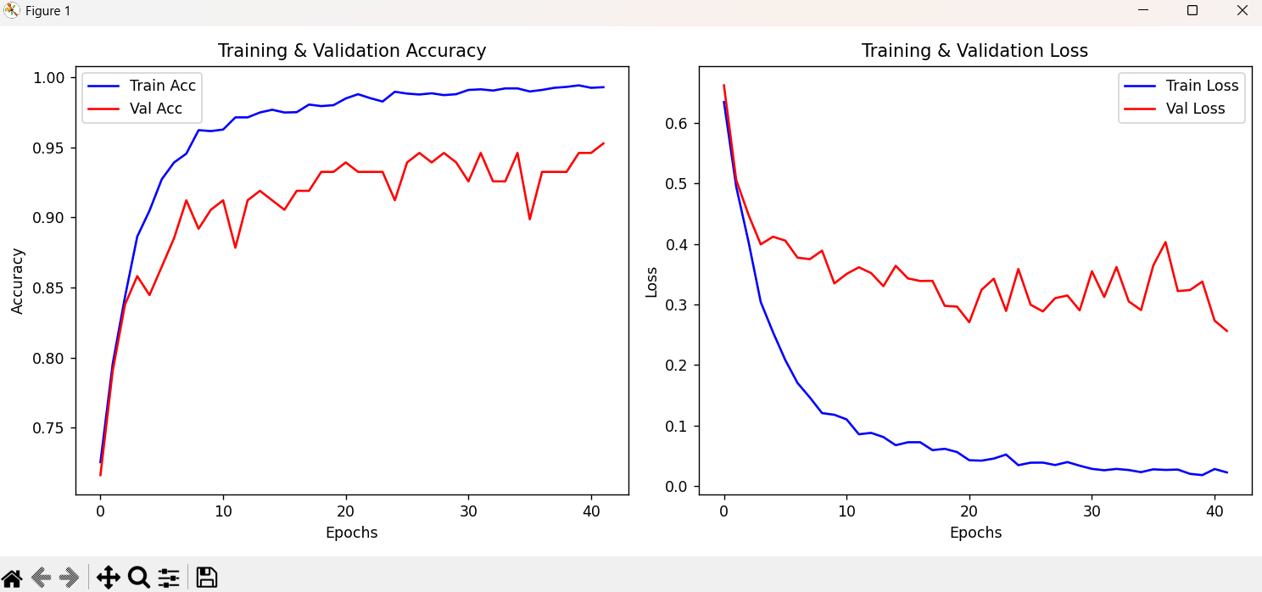

Fig 1. RESNET50 BINARY GRAPH

Model 2 — ResNet50 Four-Class Subtype Classification Results:
- The ResNet50 four-class model was used to classify CT scan images into cancer subtypes: Adenocarcinoma, Large Cell Carcinoma, Squamous Cell Carcinoma, and Normal tissue.
- The model provided detailed subtype identification following the binary screening stage, achieving 95% accuracy on the test set.
- Performance Metrics:
Accuracy: 95.0%
Precision: 94.2%
Recall: 93.8%
F1-Score: 94.0%
- Observation:
The four-class model effectively distinguished between cancer subtypes but occasionally confused Large Cell and Squamous Cell carcinoma due to visual similarities in CT appearance.

- Conclusion:
The four-class subtype classifier is essential for providing actionable diagnostic information to clinicians, enabling targeted treatment planning.

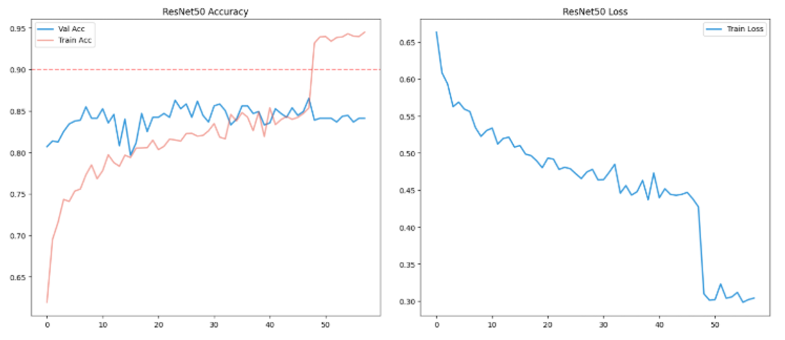

Fig 2. SUBTYPE CLASSIFICATION GRAPH

Model 3 — Dual-Layer XAI Engine (Grad-CAM + LIME) Results:

- The dual-layer XAI engine combines Grad-CAM activation mapping and LIME superpixel explanations to provide interpretable diagnostic insights.
- Grad-CAM highlights the regions of the CT scan most influential to the model's decision, while LIME identifies contributing and opposing superpixel features.

Performance Metrics:
Accuracy: ~94%
Precision: ~93%
Recall: ~92%
F1-Score: ~93%

Observation:
The XAI engine improved diagnostic transparency by providing visual evidence of model reasoning, enabling radiologists to validate AI predictions against clinical knowledge.

Conclusion:
Integrating dual-layer explainability significantly enhances clinical trust and supports evidence-based diagnostic decision-making.

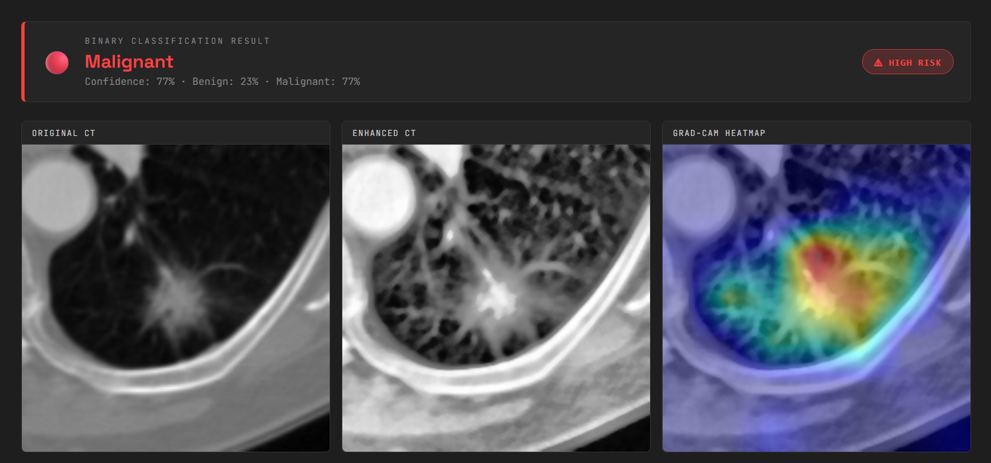

Fig 5. GRAD-CAM HEATMAP EX

Integrated System — Hierarchical Lung Cancer Diagnostic System Results:

- The final system combines dual ResNet50 models with Grad-CAM, LIME, and a clinical narrative engine in a hierarchical diagnostic pipeline.
- Predictions are validated through hierarchical classification stages with dual-layer XAI support, improving diagnostic robustness and clinical utility.

Performance Metrics (Combined System):
Accuracy: ~95%
Precision: ~94%
Recall: ~93%
F1-Score: ~94%

Observation:
The hierarchical approach significantly improved diagnostic performance compared to single-stage classification by providing both screening and detailed subtype analysis with full explainability support.

Conclusion:
The hierarchical lung cancer diagnostic system proved to be the most effective approach for comprehensive, interpretable, and clinically actionable CT-based cancer diagnosis.

